Requirements Document
Team 1: Project Templates
Submitted: August, 9, 2013

Created By:
Mohamed Baig
Elsi Nushaj

Contents

Contents 3
1 The Business Problem 4
1.1 The Business 4
1.2 Problem Statement 4
2 Stakeholders 5
3 Business Requirements Overview 6
3.1 Template Management 6
3.2 User Management 6
3.3 Milestone Management 6
3.4 Task Management 7
3.5 Category Management 7
3.6 Reuse Template 7
3.7 Download Template 8
4 Business Rules 9
5 Use Case Diagram 10
6 Use Cases 11
6.1 Use Case: Manage Templates 11
6.2 Use Case: Manage Users 14
6.3 Use Case: Manage Milestones 18
6.4 Use Case: Manage Tasks 21
6.5 Use Case: Manage Categories 24
6.6 Use Case: Reuse Template 27
6.7 Use Case: Download Template 27
7 Operational Requirements 28
7.1 Security 28
7.2 Legal 28
8 Technical Requirements 29
9 Appendices 30
9.1 Appendix A: Who Did What 30
9.2 Appendix B: Meeting Log 30

The Business Problem

The Business
This is an endeavour by our team to create a system that makes it easier for users to track and maintain their projects via templates. Users will be able to create accounts; login and download the various pre-made and user created templates in several file formats to accommodate different project management software. The templates, selected from a particular category, will create a Gantt chart in the users program. However if a template is not available, the user will be able to create their own.

Problem Statement
Two big issues with many projects is the user not knowing where to begin and what to do next. The answer to these question is not always available on the internet if the project is new. If a student or hobbyist starts their own project that they would like to complete and don't know where to start, then the templates created by others who have already done similar projects can be helpful.

Our goal is tackle such issues via the use of templates that provide pre-calculated tasks and task duration details for efficient project management. Our system will allow its user to create their own template and select from a wide variety of pre-made and user created templates for different kinds of projects. The template creates a time-line and a task list, in the program of the users choice, to be completed at certain times to complete the project. The system will be web accessible so the user will be able to access and download the templates from any web browser.

Stakeholders

Stakeholder | Role
Mohamed Baig | Authority and Business Domain Expert
Elsi Nushaj | Authority and Business Domain Expert
Barb Czegel | Business Domain Expert

Business Requirements Overview
The system contains several different components: template management, account management, milestone management, task management, category management, reuse template, download template.

Template Management
This part allows any user to create a template. Once the template is created the user is considered to be an owner of that template and can perform other tasks on the project. Templates can be public or private at owners discretion. The tasks are as follows.
Function | End User | Short Description | Use Case Containing Logic
Create template | Registered User | Ability to create a new template on their account | Manage templates
Delete template | Template Owner | Ability to delete a template | Manage templates
Update template | Template Owner | Ability to update any information about the template | Manage templates
View template | Any user | View a template | Manage templates

User Management
This part of the system allows the user to create accounts on the system. Registered users will be able to use the full potential of the web application and perform the following tasks on their accounts.
Function | End User | Short Description | Use Case Containing Logic
Create user | Any User | Ability to create an account on the system | Manage users
Update user | Account Owner | Ability to change information about account | Manage users
View user | Any User | Ability to view account information | Manage users
Delete user | Account Owner | Ability to Delete account | Manage users

Milestone Management
This part of the system allows the user to add milestones to their templates during the creation process.
Function | End User | Short Description | Use Case Containing Logic
Create milestone | Template Owner | Ability to add details about milestones | Manage milestones
Update milestone | Template Owner | Ability to update any details about milestones | Manage milestones
Delete milestones | Template Owner | Ability to delete the entire any milestones | Manage milestones
View milestones | Any user | Ability to view milestones of a template | Manage milestones

Task Management
This part of the system allows the template owner to add tasks to the template during the creation process. The functionality is as follows.
Function | End User | Short Description | Use Case Containing Logic
Create task | Template Owner | Ability for template owner to create tasks for the template during creation | Manage tasks
Delete task | Template Owner | Ability to delete any particular task | Manage tasks
Update task | Template Owner | Ability to update any particular task | Manage tasks
View task | Any user | Ability to view the list of issues | Manage tasks

Category Management
This part of the system allows the template owner to assign categories to their templates during the creation process. However, the users will not be able to create categories. New categories will be added either system updates or by system administrators. The functionality is as follows.
Function | End User | Short Description | Use Case Containing Logic
Create category | System Administrator | Ability to create a system wide category | Manage categories
Delete category | System Administrator | Ability to delete categories | Manage categories
Update category | System Administrator | Ability to update categories | Manage categories
View category | Any user | Ability to view the list of categories | Manage categories

Reuse Template
This part of the system allows a registered user to make a copy of any publicly available templates and save that copy under their own account. They can then edit the copy as they please and enhance or completely change upon the original. However, as this will be a copy the original is never changed unless the owner of the original makes changes manually.
Function | End User | Short Description | Use Case Containing Logic
Copy template | Registered user | Ability to make a copy of an already created template and save it under your account | Reuse Templates

Download Template
This part of the system allows a registered user to download a publicly available template and use it in a project management program that supports the file format.
Function | End User | Short Description | Use Case Containing Logic
Download template | Registered user | Registered users have the ability to download a template and import it into a project management program that can track the project. | Download Templates

Business Rules
Description
Users must register to create and download templates
Users can use Facebook or Google accounts to login or create an account from scratch
Any registered user can copy and modify public templates to reuse them
Templates must contain a set of tasks, milestones, and belong to a category
Template owners can delete their copy of the template
Each user must have a unique email
Each password must be a minimum of 6 characters long
Passwords must be any combination of letters from a-z, numbers from 0-9, and the following characters: @ - _ # $ &
Profile picture must be less than 1MB
Template can be in many categories
Only system administrators can create, update, and delete categories
Tasks must have at-least one dependency
Milestones must have a dependency on a task

Use Case Diagram

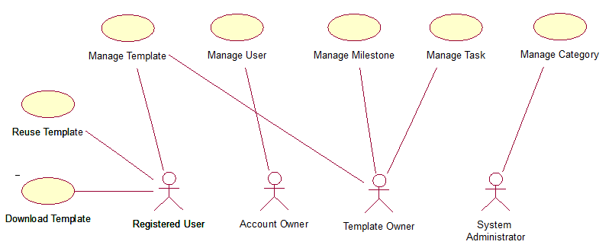

Use Cases

Use Case: Manage Templates
This use case allows the user to create, delete, update, and view templates.
Business Rules That Apply
- Template owners can delete their copy of the template
- Templates must contain a set of tasks, milestones, and belong to a category
- Any user can copy and modify public templates
- Users must register to create templates
- Template can be in categories
Default Scenario
- View template
Main Scenarios
- Create template
- Update template
- Delete template

Default Scenario: View Template
Precondition: Template owner has been authenticated
 | Actor (Template Owner) | System
 | Requests to enter template management system. | Displays a list of all templates names, descriptions, versions, unique ids, date updated, visibility, and source (if any). The option to create a new template is displayed here. Option to update and delete template are displayed beside each template.

Scenario: Create Template
Precondition: Template owner has been authenticated
 | Actor (Template Owner) | System
 | Create a new template. | Displays blank fields for the name, description, version, and visibility. The create task and create milestone buttons will be shown here. The categories are also displayed here so the template can be assigned categories.
 | Enter information for all blank fields, tasks, and milestones and submit. | System generates a unique id, date created, date updated and saves template in database. Redirection to the view templates page.

 | Alternate Flows | Description
 | Enter information for some of the blank fields and submit. | System does not save and redirects to the same page with an incomplete information error message. Blank fields with missing information are emphasized.
 | Cancels new template creation. | System discards any entered information and redirects to the view template page.

Scenario: Update template
Preconditions: Template owner has been authenticated
 | Actor (Template Owner) | System
 | Requests to update. | Fields for name, description, version, tasks, milestones and visibility are shown.
 | Milestone field is entered and submitted. | System saves changes to database, generates a new update date and redirects to the view template page.

 | Alternate Flows | Description
 | Milestone field is entered and description field is changed. | System saves changes to database, generates a new update date and redirects to the view template page.
 | Milestone field is entered and description field is removed/left blank. | System does not save and redirects to the same page with an incomplete information error message. Blank fields with missing information are emphasized.

Scenario: Delete Template
Preconditions: Template owner has been authenticated
 | Actor (Template Owner) | System
 | Requests to delete. | System displays prompt message to accept or decline.
 | Confirms template deletion. | System saves changes to database and redirects to the view templates page.

 | Alternate Flows | Description
 | Decline template deletion. | System does not save and redirects to the view templates page.

Scenario: Copy Template
Preconditions: User has been authenticated
 | Actor (User) | System
 | Requests to copy template. | System displays prompt message to accept or decline.
 | Confirms copy action. | System saves a copy of the template to database and redirects to the view templates page.

 | Alternate Flows | Description
 | Decline copy action. | System does not save and redirects to the view templates page.

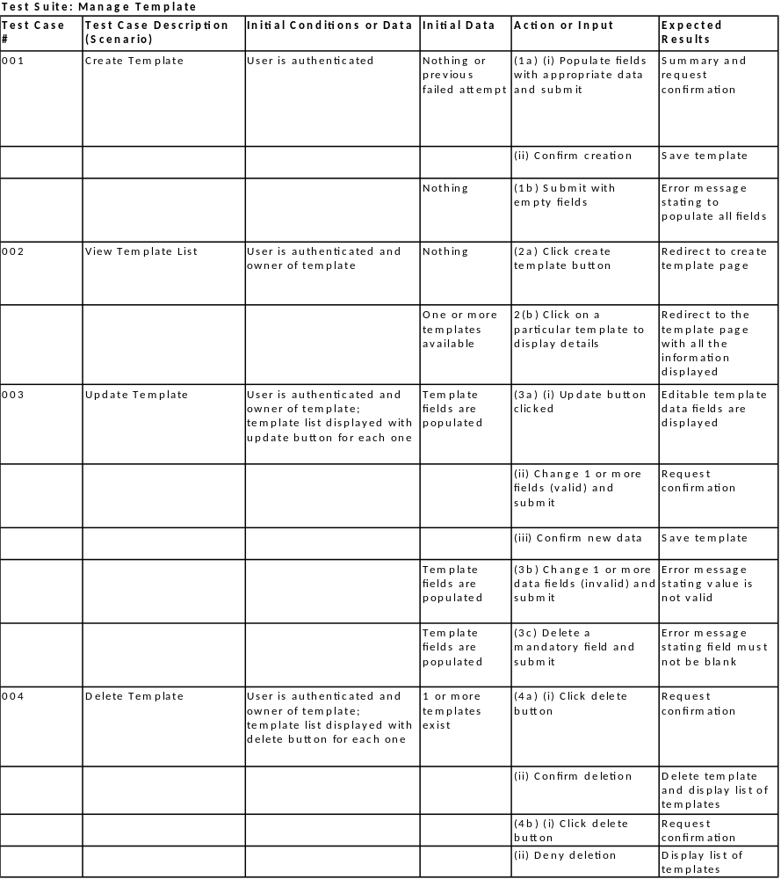

Use Case: Manage Users
This use case allows the user to create, view, update, and delete accounts.
Business Rules That Apply
- Each user must have a unique email
- Each password must be a minimum of 6 characters long
- Passwords must be any combination of letters from a-z, numbers from 0-9, and the following characters: @ - _ # $ &
- Profile picture must be less than 1MB
Default Scenario
- Create user
Main Scenarios
- View user
- Update user
- Delete user

Default Scenario: Create User
Precondition: Must be online and on the site.
 | Actor (Anyone) | System
 | Requests to create. | Displays three options to sign up via Facebook, Google, or create manually.
 | Click on Facebook button | Redirected to Facebook to authenticate with Facebook credentials and then redirected back to view account page.

 | Alternate Flows | Description
 | Click on Google button | Redirected to Google to authenticate with Google credentials and then redirected back to view account page.

 | Alternate Flows | Description
 | Click on Manual create button | Display email, First name, Last name, password, password verification, and account picture fields. Mark all fields as required except profile picture.
 | Enter all the required information meeting all the required constraints | The system sends an automatic email verification to email address entered.
 | Click on the emailed link | Saves the information to the database and redirects to the view account page

 | Alternate Flows | Description
 | Enters some information for blank fields. | System does not save and redirects to the same page with an incomplete information error message. Blank fields with missing information are emphasized.
 | Enters information for all blank fields (existing email). | System checks database for existing email with same password (match found). System does not save and redirects to the same page with an existing email error message. Blank email field is emphasized.
 | Enters information for all blank fields (password mismatch). | System checks database for existing email with same password (none found). System checks if password and password confirmation match (it does not). System does not save and redirects to the same page with a password mismatch error message. Blank password field is emphasized.
 | Enters information for all blank fields (password length). | System checks database for existing email with same password (none found). System checks if password and password confirmation match (it does). System checks if password is 6 characters long (it is not). System does not save and redirects to the same page with a password length error message. Blank password field is emphasized.
 | Enters information for all blank fields (password characters). | System checks database for existing email with same password (none found). System checks if password and password confirmation match (it does). System checks if password is 6 characters long (it is). System checks if all characters are valid (they are not). System does not save and redirects to the same page with a password character error message. Blank password field is emphasized.

Scenario: View User
Precondition: User must be authenticated.
 | Actor (User) | System
 | Requests to view account information. | Display email, first name, last name, account picture. The change password, change email, and delete account buttons are shown here.

Scenario: Update User
Preconditions: User must be authenticated.
 | Actor (User) | System
 | Requests to update Account. | Displays email, first name, last name, account picture. Change password and change email buttons are also shown here.
 | Enters information for all fields. Selects a photo and sets as account picture. Submits information. | System saves changes for text fields to database. System checks maximum account picture size (less than 1 MB). System saves changes to account picture. Redirects to view account page.

 | Alternate Flows | Description
 | Enters information for all fields. Selects a photo and sets as account picture. Submits information. | System saves changes for text fields to database. System checks maximum account picture size (exceeds 1 MB). System does not save and redirects to the same page with a account picture size error message. Blank profile account field is emphasized.
 | Cancel account update. | System discards any entered information and redirects to the view account page.

Scenario: Delete User
Preconditions: User must be authenticated.
 | Actor (User) | System
 | Requests to delete account. | System displays prompt message to accept or decline.
 | Confirms deletion. | System saves changes to database and redirects to the login.

 | Alternate Flows | Description
 | Decline deletion. | System does not save changes to database and redirects to the view account page.

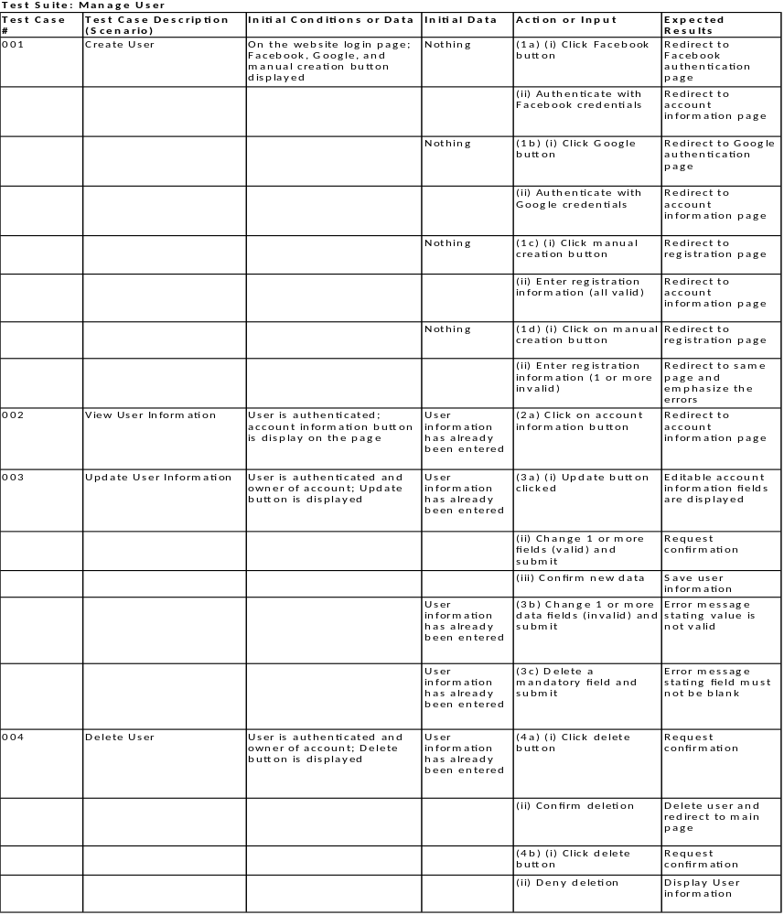

Use Case: Manage Milestones
This use case allows the template owner to create, update, view, and delete milestones from a template.
Business Rules That Apply
- Templates must contain a set of tasks, milestones, and belong to a category
- Milestones must have a dependency on a task
Default Scenario
- View milestones
Main Scenarios
- Create milestones
- Update milestones
- Delete milestones

Default Scenario: View Milestones
Precondition: The user is authenticated and viewing a template
 | Actor (User) | System
 | Request to see milestones | Display a list of milestones – title, description, set of dependencies, summary task

Scenario: Create Milestones
Precondition: The user has authenticated and creating a template
 | Actor (User) | System
 | Request to create a milestone | Display fields to be edited – title, description, summary task, set of dependencies, duration
 | Add information to the required fields and request to save | Check all fields and display confirmation
 | Confirm changes | Save milestone to the template, updates date created and re-display blank fields to add more milestones
 | Click done | Save milestones to the template and redisplays the create template page

 | Alternate Flows | Description
 | Create request cancelled | No changes are saved
 | Required fields are empty | Empty fields are highlighted and error is displayed on the same page. No changes are saved

Scenario: Update Milestones
Preconditions: The user has authenticated and updating a template
 | Actor (User) | System
 | Request to update milestones | Display update-able fields – title, description, summary task, set of dependencies
 | Update any necessary fields and request to save | Request to confirm changes
 | Confirm changes | All changes are saved to the database and user is redirected to the update page
 | Alternate Flows | Description
 | Update issue request cancelled | No changes are saved and user is redirected
 | Required fields are empty | Empty fields are highlighted and error is displayed on the same page. No changes are saved

Scenario: Delete Milestones
Preconditions: The user has authenticated updating a template
 | Actor (User) | System
 | Request to delete milestones | Request to confirm deletion
 | Confirm deletion | Delete milestones, update template and redirect to update page

 | Alternate Flows | Description
 | Deletion confirmation cancelled | No changes are saved

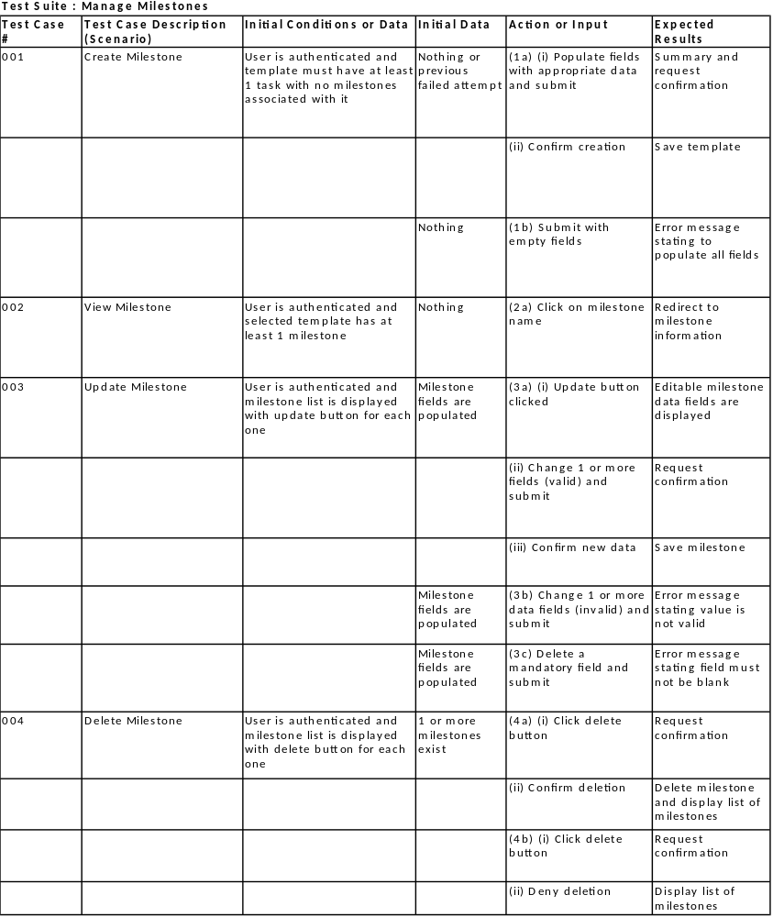

Use Case: Manage Tasks
This use case allows the template owner to create, view, update, and delete tasks.
Business Rules That Apply
- Templates must contain a set of tasks, milestones, and belong to a category
- Tasks must have at-least one dependency
Default Scenario
- View tasks
Main Scenarios
- Create tasks
- Update tasks
- Delete tasks

Default Scenario: View Tasks
Precondition: The user is authenticate and viewing a template
 | Actor (Template Owner) | System
 | Request to see tasks | Display a list of tasks – title, description, duration, summary task, set of dependencies

Scenario: Create Tasks
Precondition: The owner has authenticated and creating a template
 | Actor (Template Owner) | System
 | Request to create a task | Display fields to be edited – title, description, summary task, duration, set of dependencies
 | Add information to the required fields and request to save | Check all fields and display confirmation
 | Confirm changes | Save task to the template and redisplay the task fields to add more tasks.
 | Click done | Save template to database and redirect back to create page

 | Alternate Flows | Description
 | Create request cancelled | No changes are saved
 | Required fields are empty | Empty fields are highlighted and error is displayed on the same page. No changes are saved

Scenario: Update Tasks
Preconditions: The owner has authenticated and updating a template
 | Actor (Template Owner) | System
 | Request to update a task | Display update-able fields – title, description, duration, summary task, set of dependencies
 | Update any necessary fields and request to save | Request to confirm changes
 | Confirm changes | All changes are saved to the template and owner is redirected to the template page

 | Alternate Flows | Description
 | Update task request cancelled | No changes are saved and user is redirected
 | Required fields are empty | Empty fields are highlighted and error is displayed on the same page. No changes are saved

Scenario: Delete Tasks
Preconditions: The owner has authenticated
 | Actor (Template Owner) | System
 | Request to delete a task | Request to confirm deletion
 | Confirm deletion | Delete task, update template and database and redirect to template page

 | Alternate Flows | Description
 | Deletion confirmation cancelled | No changes are saved

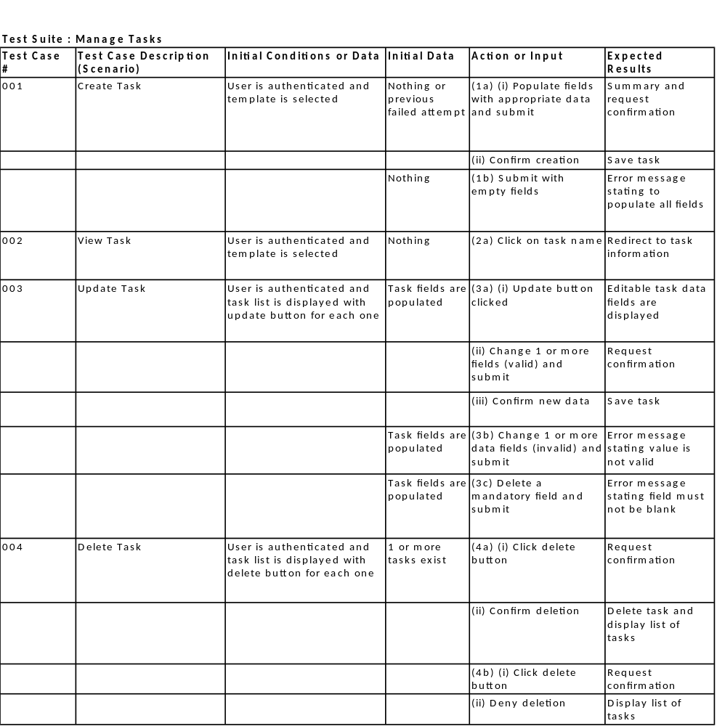

Use Case: Manage Categories
This use case allows any user to view categories. Also, it allows system administrators to create, update, and delete categories.
Business Rules That Apply
- Only system administrators can create, update, and delete categories
- Template can be in many categories
- Templates must contain a set of tasks, milestones, and belong to a category
Default Scenario
- View category
Main Scenarios
- Create category
- Update category
- Delete category
- Copy category

Default Scenario: View Category
Precondition: The user is online
 | Actor (User) | System
 | Request to see category | Display a list of templates within the selected category. If the category has sub categories than display those instead.

Scenario: Create Category
Precondition: The system administrator has authenticated
 | Actor (system administrator) | System
 | Request to create a category | Display fields to be edited – name, parent (if any), and child (if any)
 | Add information to the required fields and request to save | Check all fields and display confirmation
 | Confirm changes | Save category to the database and redirect back to create categories page

 | Alternate Flows | Description
 | Create request cancelled | No changes are saved
 | Required fields are empty | Empty fields are highlighted and error is displayed on the same page. No changes are saved

Scenario: Update Category
Preconditions: The system administrator has authenticated
 | Actor (System Administrator) | System
 | Request to update a category | Display update-able fields – name, parent (if any), and child (if any)
 | Update any necessary fields and request to save | Request to confirm changes
 | Confirm changes | Save category to the database and redirect back to update categories page

 | Alternate Flows | Description
 | Update category request cancelled | No changes are saved and user is redirected
 | Required fields are empty | Empty fields are highlighted and error is displayed on the same page. No changes are saved

Scenario: Delete Category
Preconditions: The system administrator has authenticated
 | Actor (System administrator) | System
 | Request to delete an category | Request to confirm deletion
 | Confirm deletion | Delete category, update database and redirect to view categories page

 | Alternate Flows | Description
 | Deletion confirmation cancelled | No changes are saved

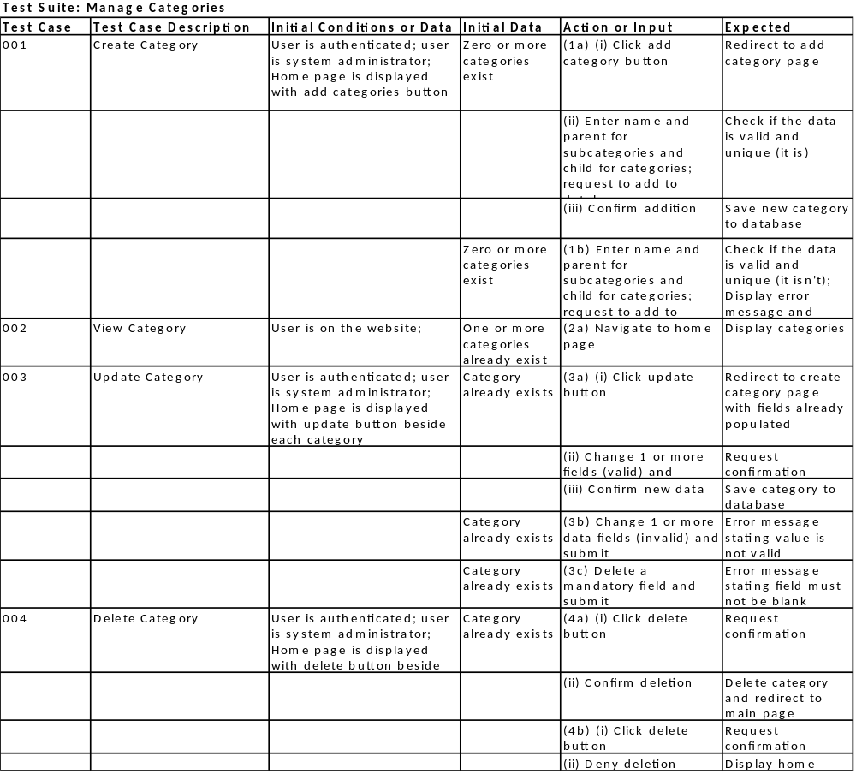

Use Case: Reuse Template
This use case allows any user to make a copy of a publicly available template and save it to their own account.
Business Rules That Apply
- Users must register to create templates
Default Scenario
- Copy Template

Default Scenario: Copy Template
Precondition: The user is authenticated
 | Actor (Registered User) | System
 | Click copy button | The template is copied into the account of the user and is available for editing.

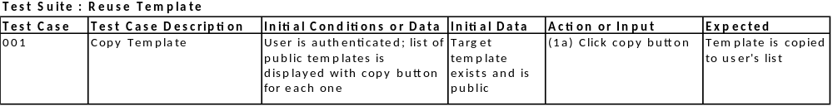

Use Case: Download Template
This use case allows any user to download a publicly available template and save it to their own computer.
Business Rules That Apply
- Users must register to download templates
Default Scenario
- Download Template

Default Scenario: Download Template
Precondition: The user is authenticated
 | Actor (Registered User) | System
 | Click download button | The template is download to the users computer.

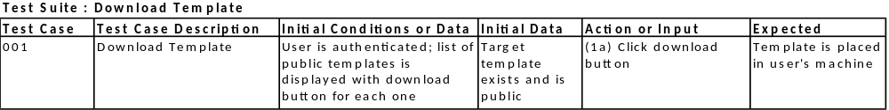

Operational Requirements

Security
- User input will first be validated to prevent SQL injection and illegal entries that may compromise the system and its data stores
- Accounts will be used to track content creation and usage and stop content abuse if necessary
- Privileges will be used on various accounts to prevent access to volatile information
- Error messages will be carefully phrased and limited to prevent hackers from gaining important information needed to bypass security validation and corrupt back end stores

Legal
The users have a right to privacy:
- All data submitted by the user will be stored on a secure server
- All data will only be used with in the system itself and not be distributed to any other company
Graphic material will be removed:
- User are not allowed to post profanity or any such graphic material
- User will be banned after three warnings have been issued

Technical Requirements
Planned technology:
- Apache server to web hosting
- MySQL for database needs
- PHP for developing
- Web-based
Reason:
- All the above mentioned technologies are readily available and cost effective. As well as being the industry standard.

Appendices

Appendix A: Who Did What
Student | Contribution
Mohamed Baig | The Business Problem, Business Requirements, Use Case: Manage Template, Use Case: Manage Accounts, Use Case: Manage Milestones, Technical Requirements
Elsi Nushaj | Use Case Diagram, Use Case: Manage Tasks, Use Case: Manage Categories, Business Rules, Operational Requirement

Appendix B: Meeting Log
Date | Location | Attendees | Description
19/07/2013 | York Campus | Mohamed, Elsi, Shavauhn | Discussed new implementation of the project and decided on an approach
21/07/2013 | York Campus | Mohamed, Elsi, Shavauhn | Decided on specifics of the new method and refined the idea
17/09/2013 | York Campus | Mohamed, Elsi, Barb | Revised the project and clarified some project details.
19/09/2013 | York Campus | Mohamed, Elsi | Reviewed the classes, requirement document, and test suites

